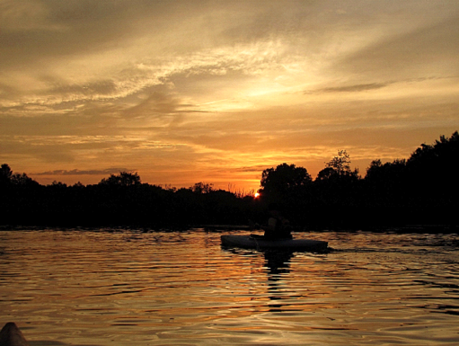
This popular event is great for the experienced paddler as well as the novice. Come to Proud Lake and paddle either a canoe or a kayak into the setting sun. Walk into Milford for dinner or dessert before continuing to paddle. When you return to the canoe rental, a bonfire will be awaiting you. No partner necessary, all skill levels welcome.
Dress for the weather, including headlamps and water bottles. Dinner NOT included in the price.

- Saturday, May 17: Full Flower Moon sunset 8:50 p.m. Paddle time: 7:45 pm
- Saturday, June 14: Full Strawberry Moon sunset 9:12 p.m. paddle time 8:00 p.m.
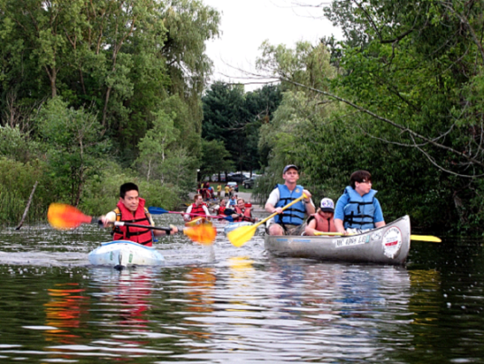
- Saturday, June 21 (Solstice canoe, paddle from the Proud Lake Campground to canoe rental. There will not be a stop in Milford this night, please have dinner before arriving) sunset 9:14 p.m. Paddle time 7:45 p.m.
- Saturday, July 12 moonrise 7:25 a.m; Full Buck Moon sunset 9:10 p.m. paddle time 8:00
- Saturday, August 9: moonrise 2:09 p.m.: Full Sturgeon Moon sunset 8:43 pm paddle time 7:00
- Saturday, September 6 (Labor Day Weekend) moonrise 9:38 pm: Full Harvest Moon 7:59 pm paddle time 6:45 p.m.
- Saturday, October 11, Full Hunter's Moon 6:58 p.m. paddle time 5:45 p.m.
- Saturday, November 8 Full Beaver Moon sunset 5:19 pm paddle time 4:00 p.m.

Cost: Canoe or Kayak $30 per person includes rental (canoe or kayak), bonfire.
Bonfire only (bring your own boat) $5 per person.
For more information call Heavner Canoe Rental at (248) 685-2379.
(Photos provided by Jeff Enterkin)

